Truncated Rhombicuboctahedron

Definition
# Source: AI Source: Provided by: [Data Path: Persons Table -> ID Column: 1, Name_En Column: Motasem Essam] -> From: [ChatGPT] on [7/25/2026]
The Truncated Rhombicuboctahedron is a polyhedron associated with the truncation of a rhombicuboctahedron. It is commonly identified with the great rhombicuboctahedron, also known as the truncated cuboctahedron in some geometric naming conventions.
It is an Archimedean solid with regular polygonal faces and the same arrangement of faces around every vertex.
Terminology note: The names truncated rhombicuboctahedron, great rhombicuboctahedron, and truncated cuboctahedron can be used inconsistently in references. The face counts and properties below refer to the great rhombicuboctahedron.

Geometric Structure
# Source: AI Source: Provided by: [Data Path: Persons Table -> ID Column: 1, Name_En Column: Motasem Essam] -> From: [ChatGPT] on [7/25/2026]
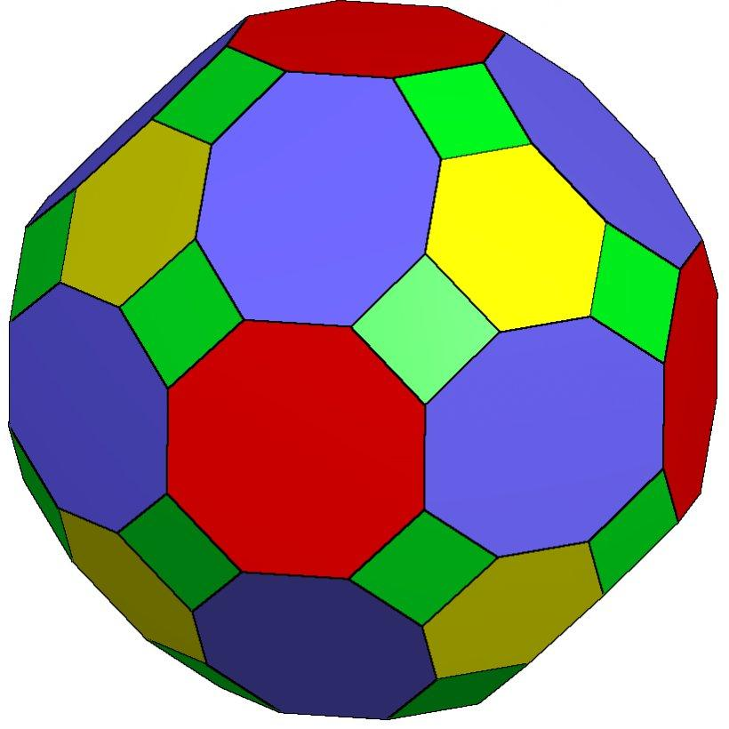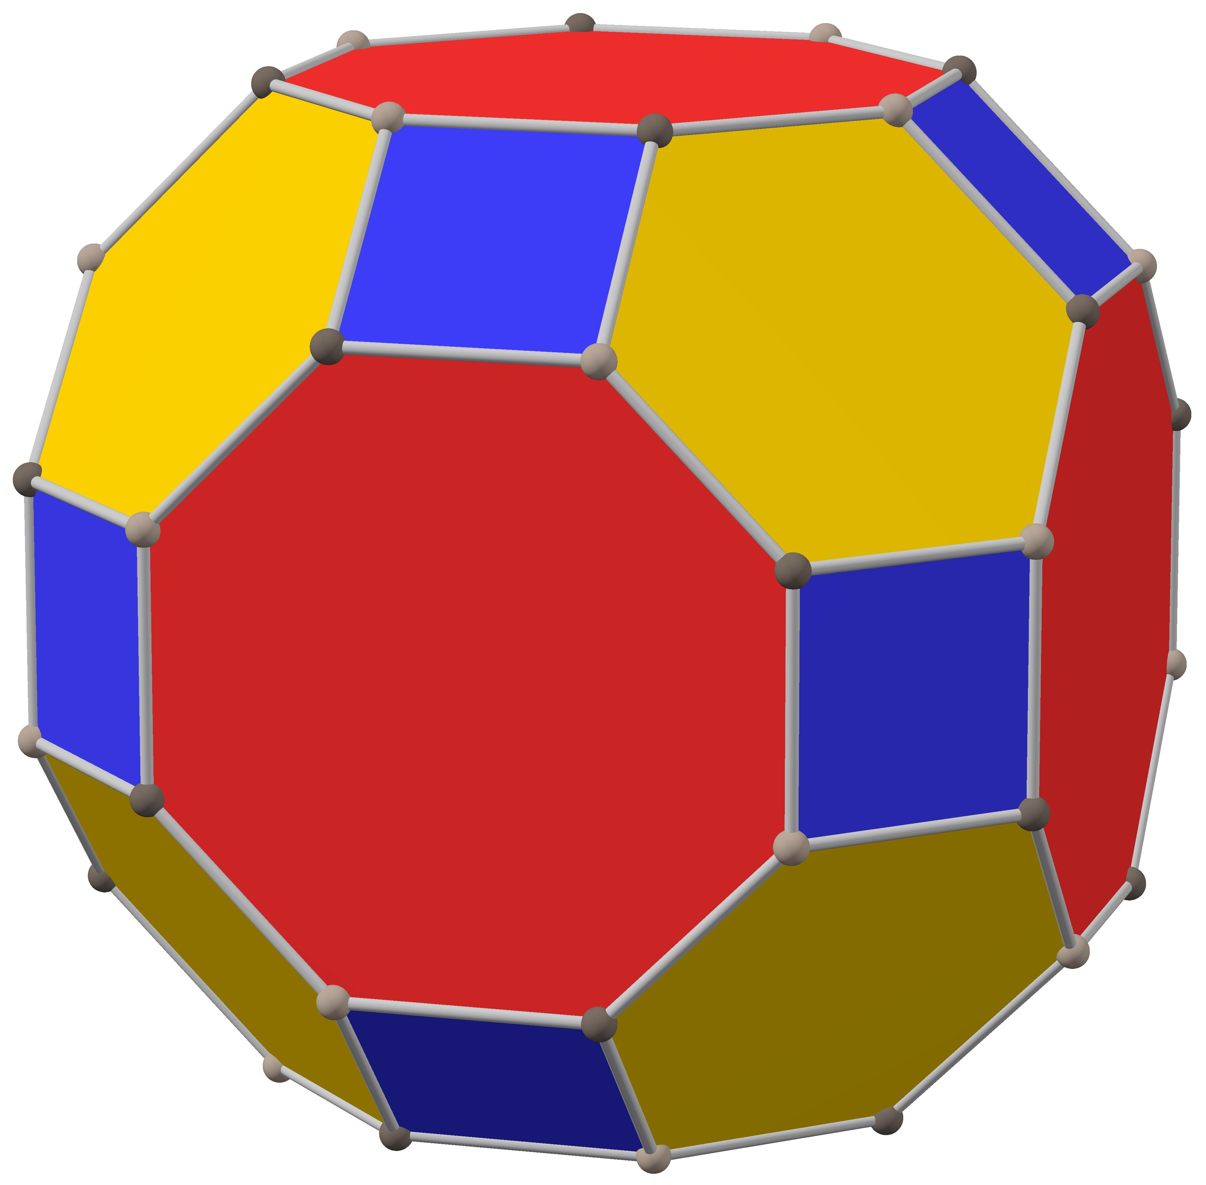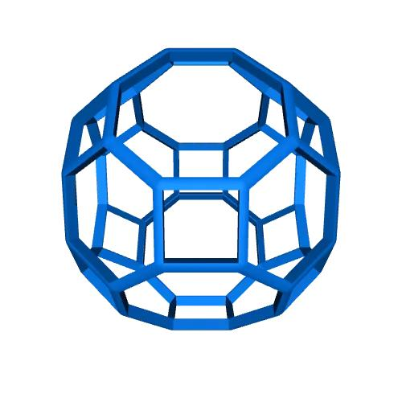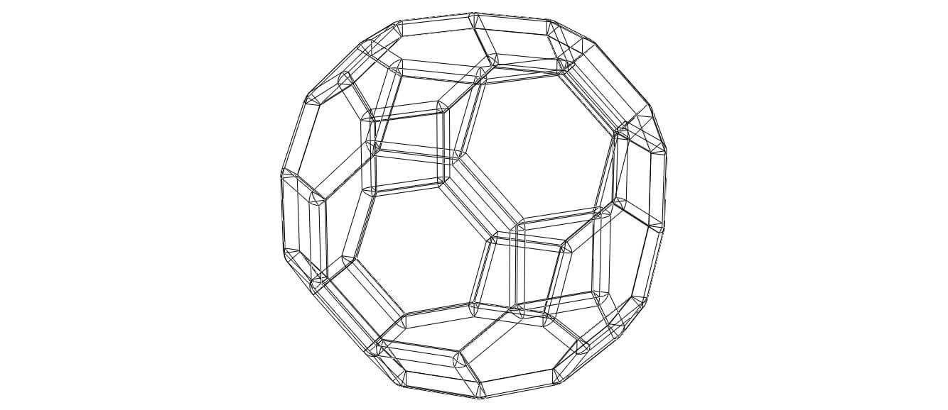
- It is formed by truncating the vertices of a small rhombicuboctahedron.
- The truncation creates additional faces and modifies the original square and triangular faces.
- It has a convex, highly symmetrical structure. <Cite refs={["turn535094search15","turn535094search0"]}/>

Face Composition
# Source: AI Source: Provided by: [Data Path: Persons Table -> ID Column: 1, Name_En Column: Motasem Essam] -> From: [ChatGPT] on [7/25/2026]
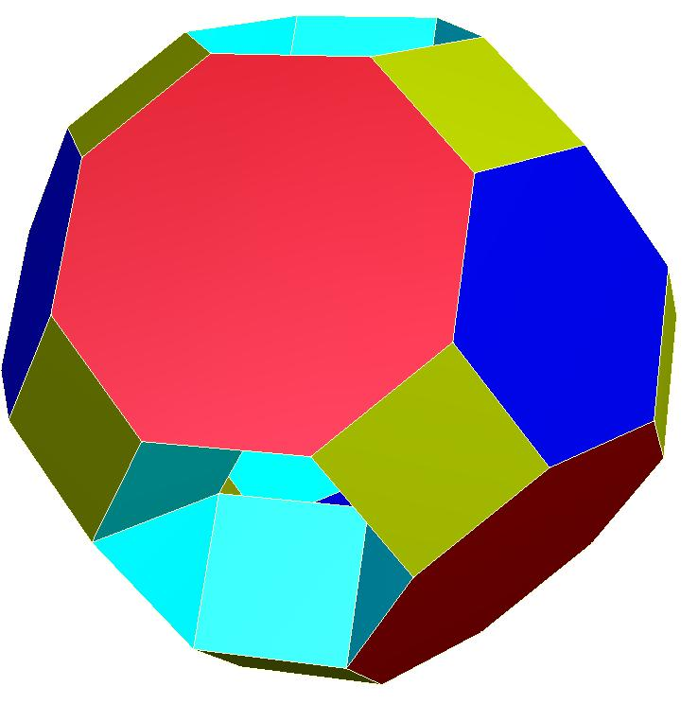

Square Faces
# Source: AI Source: Provided by: [Data Path: Persons Table -> ID Column: 1, Name_En Column: Motasem Essam] -> From: [ChatGPT] on [7/25/2026]
Four-sided faces inherited from the original structure and created through truncation.

Hexagonal Faces
# Source: AI Source: Provided by: [Data Path: Persons Table -> ID Column: 1, Name_En Column: Motasem Essam] -> From: [ChatGPT] on [7/25/2026]
Six-sided faces produced by truncating the original triangular faces.

Octagonal Faces
# Source: AI Source: Provided by: [Data Path: Persons Table -> ID Column: 1, Name_En Column: Motasem Essam] -> From: [ChatGPT] on [7/25/2026]
Eight-sided faces, including faces formed around the original square faces.
<text color="secondary" size="xs">Face composition: 24 squares + 8 hexagons + 18 octagons = 50 faces. Not all octagonal faces are regular. <Cite refs={["turn535094search15"]}/></text>

Mathematical Properties
# Source: AI Source: Provided by: [Data Path: Persons Table -> ID Column: 1, Name_En Column: Motasem Essam] -> From: [ChatGPT] on [7/25/2026]
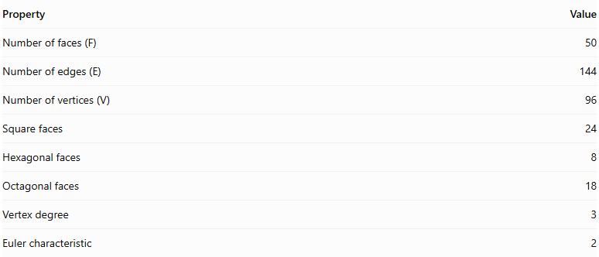
Property | Value
Number of faces (F) | 50
Number of edges (E) | 144
Number of vertices (V) | 96
Square faces | 24
Hexagonal faces | 8
Octagonal faces | 18
Vertex degree | 3
Euler characteristic | 2
Euler's Formula
$$V-E+F=2$$
$$96-144+50=2$$
<Cite refs={["turn535094search15"]}/>

Key Points
# Source: AI Source: Provided by: [Data Path: Persons Table -> ID Column: 1, Name_En Column: Motasem Essam] -> From: [ChatGPT] on [7/25/2026]
- It is constructed by truncating a small rhombicuboctahedron.
- It contains 50 faces, 144 edges, and 96 vertices.
- Its faces consist of squares, hexagons, and octagons.
- It is a convex polyhedron and a zonohedron.
- It is not an Archimedean solid, because its faces and vertex arrangements do not satisfy the Archimedean uniformity requirements. <Cite refs={["turn535094search15"]}/>
Important distinction between similar names:
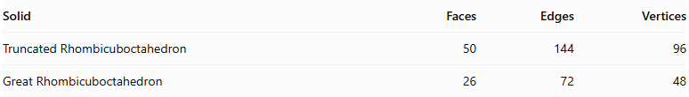
Solid | Faces | Edges | Vertices
Truncated Rhombicuboctahedron | 50 | 144 | 96
Great Rhombicuboctahedron | 26 | 72 | 48
The Great Rhombicuboctahedron is the Archimedean solid with 12 squares, 8 hexagons, and 6 octagons. It is also sometimes called the truncated cuboctahedron—not the truncated rhombicuboctahedron.

Conclusion
# Source: AI Source: Provided by: [Data Path: Persons Table -> ID Column: 1, Name_En Column: Motasem Essam] -> From: [ChatGPT] on [7/25/2026]
The Truncated Rhombicuboctahedron is a convex polyhedron formed by truncating a small rhombicuboctahedron. It has 50 faces composed of 24 squares, 8 hexagons, and 18 octagons, together with 144 edges and 96 vertices.
Although it belongs to the family of truncated polyhedra, it should not be classified as an Archimedean solid.

